Syntax-Directed Translation

Syntax-directed translation (SDT) refers to a method of compiler implementation
where the source language translation is completely driven by the parser, i.e., based on
the syntax of the language The parsing process and parse trees are used to direct
Semantic analysis and the translation of the source program. Almost all modern compilers
are syntax-directed.
SDT can be a separate phase of a compiler or we can augment our conventional grammar
with information to control the semantic analysis and translation. Such grammars are
called attribute grammars.
We augment a grammar by associating attributes with each grammar symbol that
describes its properties. With each production in a grammar, we give semantic rules/
actions, which describe how to compute the attribute values associated with each
grammar symbol in a production.
The general approach to Syntax-Directed Translation is to construct a parse tree or syntax
tree and compute the values of attributes at the nodes of the tree by visiting them in some
order. In many cases, translation can be done during parsing without building an explicit
tree.
A class of syntax-directed translations called "L-attributed translations" (L for left-to-
right) includes almost all translations that can be performed during parsing. Similarly,
"S-attributed translations" (S for synthesized) can be performed easily in connection with
a bottom-up parse.
There are two ways to represent the semantic rules associated with grammar symbols.

•
•
Syntax-Directed Definitions (SDD)
Syntax-Directed Translation Schemes (SDT)

Syntax-Directed Definitions
A syntax-directed definition (SDD) is a context-free grammar together with attributes and
rules. Attributes are associated with grammar symbols and rules are associated with
productions.
An attribute has a name and an associated value: a string, a number, a type, a memory
location, an assigned register, strings. The strings may even be long sequences of code,
say code in the intermediate language used by a compiler. If X is a symbol and a is one of
its attributes, then we write X.a to denote the value of a at a particular parse-tree node
labeled X. If we implement the nodes of the parse tree by records or objects, then the
attributes of X can be implemented by data fields in the records that represent the nodes
for X. The attributes are evaluated by the semantic rules attached to the productions.

Example:
PRODUCTION
E → E1 + T
SEMANTIC RULE
E.code = E1.code || T.code || ‘+’

SDDs are highly readable and give high-level specifications for translations. But they
hide many implementation details. For example, they do not specify order of evaluation
of semantic actions.

1

Syntax-Directed Translation Schemes (SDT)
SDT embeds program fragments called semantic actions within production bodies. The
position of semantic action in a production body determines the order in which the action
is executed.
Example: In the rule E → E1 + T { print ‘+’ }, the action is positioned after the body
of the production.
SDTs are more efficient than SDDs as they indicate the order of evaluation of semantic
actions associated with a production rule. This also gives some information about
implementation details.
Inherited and Synthesized Attributes
Terminals can have synthesized attributes, which are given to it by the lexer (not the
parser). There are no rules in an SDD giving values to attributes for terminals. Terminals
do not have inherited attributes.
A nonterminal A can have both inherited and synthesized attributes. The difference is
how they are computed by rules associated with a production at a node N of the parse
tree.

•

•
A synthesized attribute for a nonterminal A at a parse-tree node N is defined by
a semantic rule associated with the production at N. Note that the production must
have A as its head.
A synthesized attribute at node N is defined only in terms of attribute values at
the children of N and at N itself.
An inherited attribute for a nonterminal B at a parse-tree node N is defined by a

semantic rule associated with the production at the parent of N. Note that the
production must have B as a symbol in its body.
An inherited attribute at node N is defined only in terms of attribute values
at N's parent, N itself, and N's siblings.
An inherited attribute at node N cannot be defined in terms of attribute values at the
children of node N. However, a synthesized attribute at node N can be defined in terms of
inherited attribute values at node N itself.

Example 5.1: The SDD in Fig. 5.1 is based on grammar for arithmetic expressions with
operators + and *. It evaluates expressions terminated by an endmarker n. In the SDD,

2

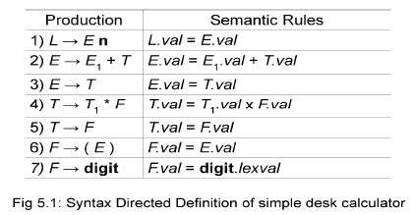

each of the nonterminals has a single synthesized attribute, called val. We also suppose
that the terminal digit has a synthesized attribute lexval, which is an integer value
returned by the lexical analyzer.
An SDD that involves only synthesized attributes is called S-attributed; the SDD in Fig.
5.1 has this property. In an S-attributed SDD, each rule computes an attribute for the
nonterminal at the head of a production from attributes taken from the body of the
production.
Attribute Grammar: An SDD without side effects is sometimes called an attribute
grammar. The rules in an attribute grammar define the value of an attribute purely in
terms of the values of other attributes and constants.
Evaluating an SDD at the Nodes of a Parse Tree
Parse tree helps us to visualize the translation specified by SDD. The rules of an SDD are
applied by first constructing a parse tree and then using the rules to evaluate all of the
attributes at each of the nodes of the parse tree. A parse tree, showing the value(s) of its
attribute(s) is called an annotated parse tree.
With synthesized attributes, we can evaluate attributes in any bottom-up order, such as
that of a postorder traversal of the parse tree.
Example: Annotated Parse Tree for 3*5+4n

Inherited attributes are useful when the structure of a parse tree does not match the
abstract syntax of the source code. They can be used to overcome the mismatch due to
grammar designed for parsing rather than translation.
In the SDD below, the nonterminal T has an inherited attribute inh as well as a
synthesized attribute val. T inherits F.val from its left sibling F in the production
T → FT .

3

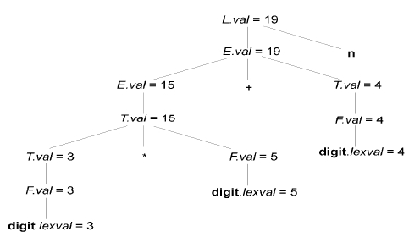

SDD for expression grammar with inherited attributes
Annotated Parse Tree for 3*5 using the above SDD is as below.

An SDD with both inherited and synthesized attributes does not ensure any guaranteed
order; even it may not have an order at all. For example, consider nonterminals A and B,
with synthesized and inherited attributes A.s and B.i, respectively, along with the
production and rules as in Fig.5.2. These rules are circular; it is impossible to evaluate
either A.s at a node N or B.i at the child of N without first evaluating the other. The
circular dependency of A.s and B.i at some pair of nodes in a parse tree is suggested by
Fig.5.2.

.
Evaluation Orders for SDD's
"Dependency graphs" are a useful tool for determining an evaluation order for the
attribute instances in a given parse tree. While an annotated parse tree shows the values
of attributes, a dependency graph helps us determine how those values can be computed.
A dependency graph shows the flow of information among the attribute instances in a
particular parse tree; an edge from one attribute instance to another means that the value

4

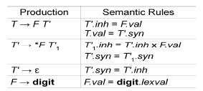

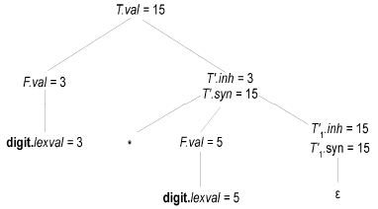

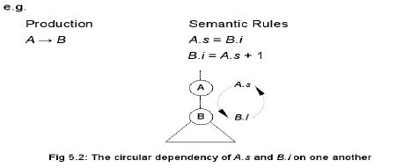

of the first is needed to compute the second. Edges express constraints implied by the
semantic rules.

·
·

·
Each attribute is associated to a node
If a semantic rule associated with a production p defines the value of synthesized
attribute A.b in terms of the value of X.c, then graph has an edge from X.c to A.b
If a semantic rule associated with a production p defines the value of inherited

attribute B.c in terms of value of X.a, then graph has an edge from X.a to B.c
Example: Dependency graph for the annotated parse tree for 3*5

Topological Sort of the Dependency Graph
A dependency graph characterizes the possible order in which we can evaluate the
attributes at various nodes of a parse tree. If there is an edge from node M to N, then
attribute corresponding to M first be evaluated before evaluating N. Thus the only
allowable orders of evaluation are N1, N2, ..., Nk such that if there is an edge from Ni to
Nj then i < j. Such an ordering embeds a directed graph into a linear order, and is called a
topological sort of the graph.
If there is any cycle in the graph, then there are no topological sorts; that is, there is no
way to evaluate the SDD on this parse tree. If there are no cycles, however, then there is
always at least one topological sort.
Example: Topological sorts for the above the dependency graph is shown in a simplified
fashion with the nodes indicating the nodes of the parse tree and the edges indicating
precedence of evaluation. It is apparent that the last section of the dependence graph
denoted by the nodes { 6 7 8 9 } needs to be evaluated in sequence. The only flexibility
of the order of evaluation is on the two sub-sequences { 1 3 5 } and { 2 4 } which can
with any interleaving provided the relative order of their nodes is preserved are as below.

5

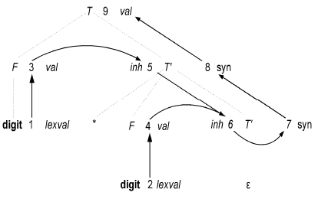

Base sequences are {1 3 5} and {2 4} with the suffix {6 7 8 9} being constant as the last
nodes of the topological sorting need to remain fixed.
1 3 5 2 4 6 7 8 9, 1 3 2 5 4 6 7 8 9, 1 2 3 5 4 6 7 8 9, 1 3 2 4 5 6 7 8 9, 1 2 3 4 5 6 7 8 9,
1 2 4 3 5 6 7 8 9, 2 1 3 5 4 6 7 8 9, 2 1 3 4 5 6 7 8 9, 2 1 4 3 5 6 7 8 9, 2 4 1 3 5 6 7 8 9
S-Attributed Definitions
An SDD is S-attributed if every attribute is synthesized. Attributes of an S-attributed
SDD can be evaluated in bottom-up order of the nodes of parse tree. Evaluation is simple
using post-order traversal.
postorder(N) {
for (each child C of N, from the left)
postorder(C);
evaluate attributes associated with node N;
}
S-attributed definitions can be implemented during bottom-up parsing as

–
–
bottom-up parse corresponds to a postorder traversal
postorder corresponds to the order in which an LR parser reduces a

production body to its head
L-Attributed Definitions
The idea behind this class is that, between the attributes associated with a production
body, dependency-graph edges can go from left to right, but not from right to left(hence
"L-attributed"). Each attribute must be either
1. Synthesized, or
2. Inherited, but with the rules limited as follows. Suppose that there is a production
A→ X1 X2 · · · Xn, and that there is an inherited attribute Xi.a computed by a rule
associated with this production. Then the rule may use only:
(a) Inherited attributes associated with the head A.
(b) Either inherited or synthesized attributes associated with the occurrences of
symbols X1 X2 · · · Xi-1 located to the left of Xi
(c) Inherited or synthesized attributes associated with this occurrence of Xi
itself, but only in such a way that there are no cycles in a dependency graph
formed by the attributes of this Xi.
Example 1: The following definition is L-attributed. Here the inherited attribute of T gets
its values from its left sibling F. Similarly, T1 gets its value from its parent T and left
sibling F.

6

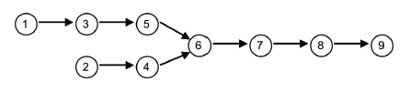

Example 2: the definitions below are not L-attributed as B.i depends on its right sibling
C’s attribute.

Side Effects: Evaluation of semantic rules may generate intermediate codes, may put
information into the symbol table, may perform type checking and may issue error
messages. These are known as side effects.
Semantic Rules with Controlled Side Effects:
In practice translation involves side effects. Attribute grammars have no side effects and
allow any evaluation order consistent with dependency graph whereas translation
schemes impose left-to-right evaluation and allow schematic actions to contain any
program fragment.
Ways to Control Side Effects
1. Permit incidental side effects that do not disturb attribute evaluation.
2. Impose restrictions on allowable evaluation orders, so that the same translation is
produced for any allowable order.
SDD For Simple Type Declarations

Nonterminal D represents a declaration, which, from production 1, consists of a type T
followed by a list L of identifiers. T has one attribute, T.type, which is the type in the
declaration D. Nonterminal L also has one attribute, which we call ink to emphasize that
it is an inherited attribute. The purpose of L.inh is to pass the declared type down the list
of identifiers, so that it can be the appropriate symbol-table entries. Productions 2 and 3
each evaluate the synthesized attribute T.type, giving it the appropriate value, integer or
float. This type is passed to the attribute L.inh in the rule for production 1. Production 4
passes L.inh down the parse tree. That is, the value L1.inh is computed at a parse-tree
node by copying the value of L.inh from the parent of that node; the parent corresponds
to the head of the production. Productions 4 and 5 also have a rule in which a function
addType is called with two arguments:
1. id.entry, a lexical value that points to a symbol-table object, and
2. L.inh, the type being assigned to every identifier on the list.

7

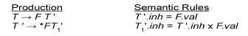

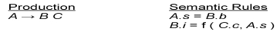

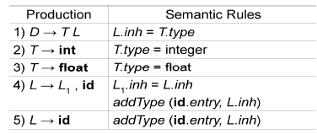

The function addType properly installs the type L.inh as the type of the represented
identifier. Note that the side effect, adding the type info to the table, does not affect the
evaluation order.
A dependency graph for the input string float id1 , id 2, id3 is shown below.

Applications of Syntax-Directed Translations

1: Construction of Syntax Trees

SDDs are useful for is construction of syntax trees. A syntax tree is a condensed
form of parse tree.

·

·
·

Syntax trees are useful for representing programming language constructs like
expressions and statements.
They help compiler design by decoupling parsing from translation.
Each node of a syntax tree represents a construct; the children of the node
represent the meaningful components of the construct.

·
e.g. a syntax-tree node representing an expression E1 + E2 has label +
and two children representing the sub expressions E1 and E2

·
Each node is implemented by objects with suitable number of fields; each object

will have an op field that is the label of the node with additional fields as follows:
If the node is a leaf, an additional field holds the lexical value for the
leaf . This is created by function Leaf(op, val)
If the node is an interior node, there are as many fields as the node has
children in the syntax tree. This is created by function Node(op, c1, c2,...,ck) .

8

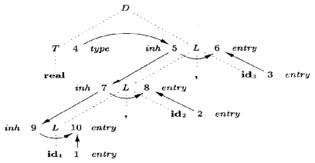

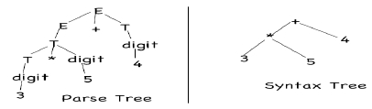

Example: The S-attributed definition in figure below constructs syntax trees for a simple
expression grammar involving only the binary operators + and -. As usual, these
operators are at the same precedence level and are jointly left associative. All
nonterminals have one synthesized attribute node, which represents a node of the syntax
tree.

Syntax tree for a-4+c using the above SDD is shown below.

Steps in the construction of the syntax tree for a-4+c
If the rules are evaluated during a post order traversal of the parse tree, or with reductions
during a bottom-up parse, then the sequence of steps shown below ends with p5 pointing
to the root of the constructed syntax tree.

Constructing Syntax Trees during Top-Down Parsing
With a grammar designed for top-down parsing, the same syntax trees areconstructed,
using the same sequence of steps, even though the structure of the parse trees differs
significantly from that of syntax trees. The L-attributed definition below performs the
same translation as the S-attributed definition shown before.

9

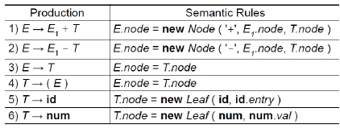

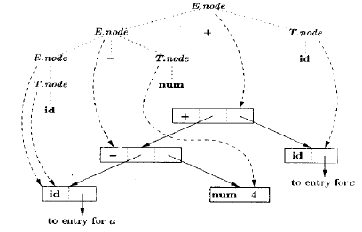

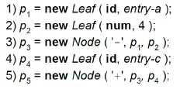

Dependency Graph for a-4+c with L-Attributed SDD

Structure of a Type
This is an example of how inherited attributes can be used to carry information one part
of the parse tree to another. In C, the type int [2][3] can be read as, "array of 2 arrays of 3
integers." The corresponding type expression array(2, array(3, integer)) is represented by
the tree as shown below.

10

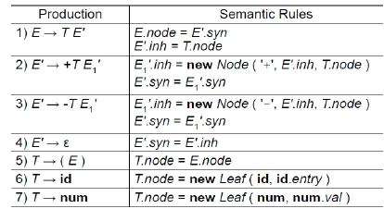

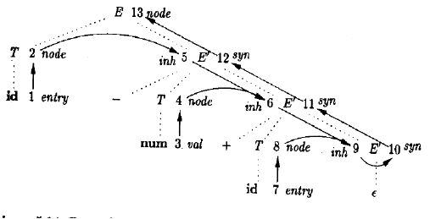

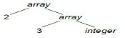

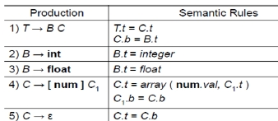

The nonterminals B and T have a synthesized attribute t representing a type. The
nonterminal C has two attributes: an inherited attribute b and a synthesized attribute t.
The inherited b attributes pass a basic type down the tree, and the synthesized t attributes
accumulate the result.
An annotated parse tree for the input string int [2][3] is shown below. The corresponding
type expression is constructed by passing the type integer from B, down the chain of C's
through the inherited attributes b. The array type is synthesized up the chain of C's
through the attributes t.

Syntax Directed Translation Schemes
SDT is a complementary notation to SDD. All applications of SDD can be implemented
using SDT. SDT is a context-free grammar with program fragments called semantic
actions embedded within production bodies.
Any SDT can be implemented by first building a parse tree and then performing the
actions in a left-to-right depth-first order i.e. during a pre-order traversal. Typically SDT's
are implemented during parsing without building parse tree. During parsing, an action in
a production body is executed as soon as all the grammar symbols to the left of action
have been matched.
SDT's that can be implemented during parsing can be characterized by introducing
distinct marker nonterminals in place of each embedded action. Each marker M has only
one production M → ε. If grammar with marker nonterminals can be parsed by a given
method, then the SDT can be implemented during parsing.
Postfix Translation Schemes

The simplest implementation of SDD occurs when we can parse the grammar bottom-up
and SDD is S-attributed. Here, each semantic action can be placed at the end of
production and executed along with the reduction of body to the head of the production.
This type of SDT is called Postfix SDT.

Example: Postfix SDT for implementing the desk calculator is as below.

11

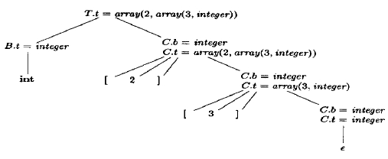

Parser-Stack Implementation of Postfix SDTs

Postfix SDT’s can be implemented during LR parsing.
Attribute of each grammar

symbol can be put on the stack in place where they can be found during reduction, i.e..
place attribute along with grammar symbol in record of stack itself.

Fig. parser stack with field for synthesised attributes
To implement SDT during LR parsing, add semantic stack parallel to the parsing stack:
each symbol (terminal or non-terminal) on the parsing stack stores its value on the
semantic stack. It holds terminals’ attributes and nonterminals’ translations. When the
parse is finished, the semantic stack will hold just one value: the translation of the root
non-terminal (which is the translation of the whole input).
Semantic Actions during Parsing

·

·
when shifting
– push the value of the terminal on the semantic stack
when reducing

– pop k values from the semantic stack, where k is the number of symbols
on production’s RHS
– push the production’s value on the semantic stack

The SDT for implementing the desk calculator on a bottom-up parsing stack is as above.

12
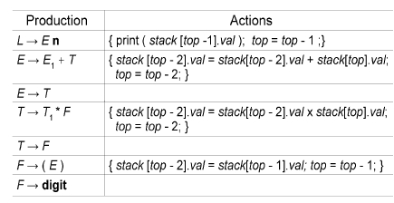

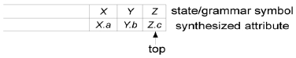

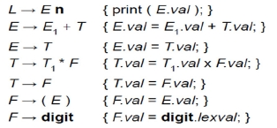

SDTs with Actions inside Productions

·
·
·
Action can be placed at any position in the production body.
Action is performed immediately after all symbols left to it are processed.
Given B —> X { a } Y , an action a is done after

–
–
we have recognized X (if X is a terminal), or
all terminals derived from X (if X is a nonterminal).

·

·
If bottom-up parser is used, then action a is performed as soon as X appears on
top of the stack.
If top-down parser is used, then action a is performed

–
–
just before Y is expanded (if Y is nonterminal), or
check Y on input (if Y is a terminal).

·
Any SDT can be implemented as follows:

–
–
–
Ignoring actions, parse input and produce parse tree.
Add additional children to node N for action in α, where A → α.
Perform preorder traversal of the tree, and as soon as a node labeled by an

action is visited, perform that action.

SDT for infix-to-prefix translation during parsing

Parse Tree with Actions Embedded

Eliminating Left Recursion from SDTs
Grammar with left recursion cannot be parsed using top-down parser. In case of SDT we
treat action as terminal symbol in the production. Then we use the following rule of
transforming grammar to non left-recursive form.

13

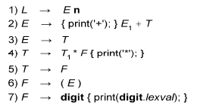

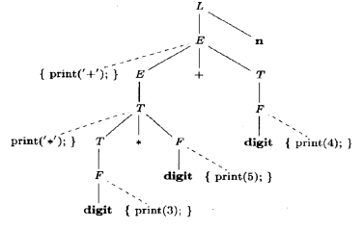

A → Aα | β can be transformed to A → β R,

R → αR | ε

In both forms, A is defined by β(α)*

Example: Given E → E1+ T { print(’+’); } and E → T. Here α = + T { print(’+’); } and
β = T . Modified grammar will be: E → T R, R → + T { print(’+’); } R , R → ε .

More general example: A → A1 Y {A.a=g(A1.a, Y.y)}
A → X {A.a = f(X.x)} can be rewritten as
A → X { R.i= f( X.x )} R {A.a = R.s}
R → Y { R1.i = g(R.i, Y.y) } R1 { R.s = R1.s }
R → ε { R.s = R.i}

SDTs for L-Attributed Definitions

·
·
It is necessary that the underlying grammar can be parsed top-down
Rules to modify L-attributed SDD to SDT

– Embed the action for computing inherited attributes for a nonterminal A
immediately before A in production body
– Place the action for computing synthesized attribute for the head at the end
of the body of production
Example 1: This example is motivated by languages for typesetting mathematical
formulas. Eqn is an early example of such a language. It illustrates how the techniques of
compiling can be used in language processing for applications other than programming
languages.

14

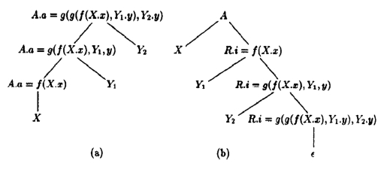

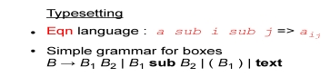

Corresponding to these four productions, a box can be either
1. Two boxes, juxtaposed, with the first, B1, to the left of the other, B2.
2. A box and a subscript box. The second box appears in a smaller size, lower, and to the
right of the first box.
3. A parenthesized box, for grouping of boxes and subscripts.
4. A text string, that is, any string of characters.

SDD for Typesetting Boxes

SDT for typesetting boxes

15

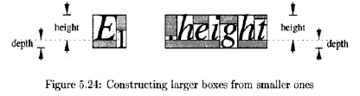

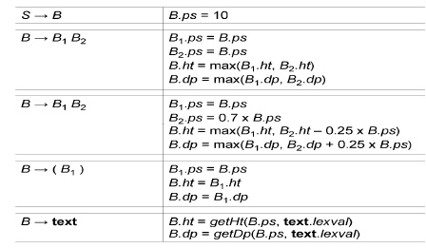

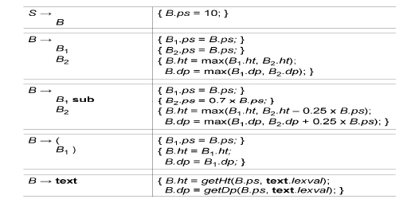

Example 2: The second example is about the generation of intermediate code for a
typical programming-language construct: a form of while-statement.

SDD for while-statements

SDT for while-statements

16

